## What Else Should I Know?

**Online Community** - The Sierra PTO maintains an active website, Facebook page, and Twitter feed. Check our website and follow us on Facebook and Twitter to stay informed on all upcoming events and fundraisers.



www.sierrapto.org

facebook.com/SierraPTO



twitter.com/SierraPTO

**General Meetings** - The PTO holds meetings roughly once a month to communicate news and hear input from our members. All parents are encouraged to attend.

**Executive Board Elections** - The PTO Board, which oversees the day-to-day operations of the organization, is comprised of parent volunteers and is elected once each year during the March/April timeframe. All parents are encouraged to submit nominees and vote.

## How can I Become Involved?

Contact one of our board members (contact information appears on the back of this brochure) and we will be happy to answer any questions you may have. You can even stop us in the hall, as we're often at school wearing our PTO badges. Visit sierrapto.com for info too. Come talk to any one of us and get involved!

## ..\..\..\Documents\SierraPTO\Logos\PTO\PTO2012-Logo.pngPTO board members

**2014-2015 School Year**

**Monica Gellman**President  
[president@sierrapto.org](mailto:president@sierrapto.org)

**Niccoli Anderson & Mitch Klann**co-Vice Presidents  
[vp@sierrapto.org](mailto:vp@sierrapto.org)

**Amanda Holtom & Pam Lang**Co-Secretaries  
[secretary@sierrapto.org](mailto:secretary@sierrapto.org)

**Shannon Reagan**Treasurer  
[treasurer@sierrapto.org](mailto:treasurer@sierrapto.org)

**Dee Hruschka**Financial Admin  
[financial@sierrapto.org](mailto:financial@sierrapto.org)

**Bethany Brown**Volunteer Coordinator  
[volunteercoord@sierrapto.org](mailto:communications@sierrapto.org)

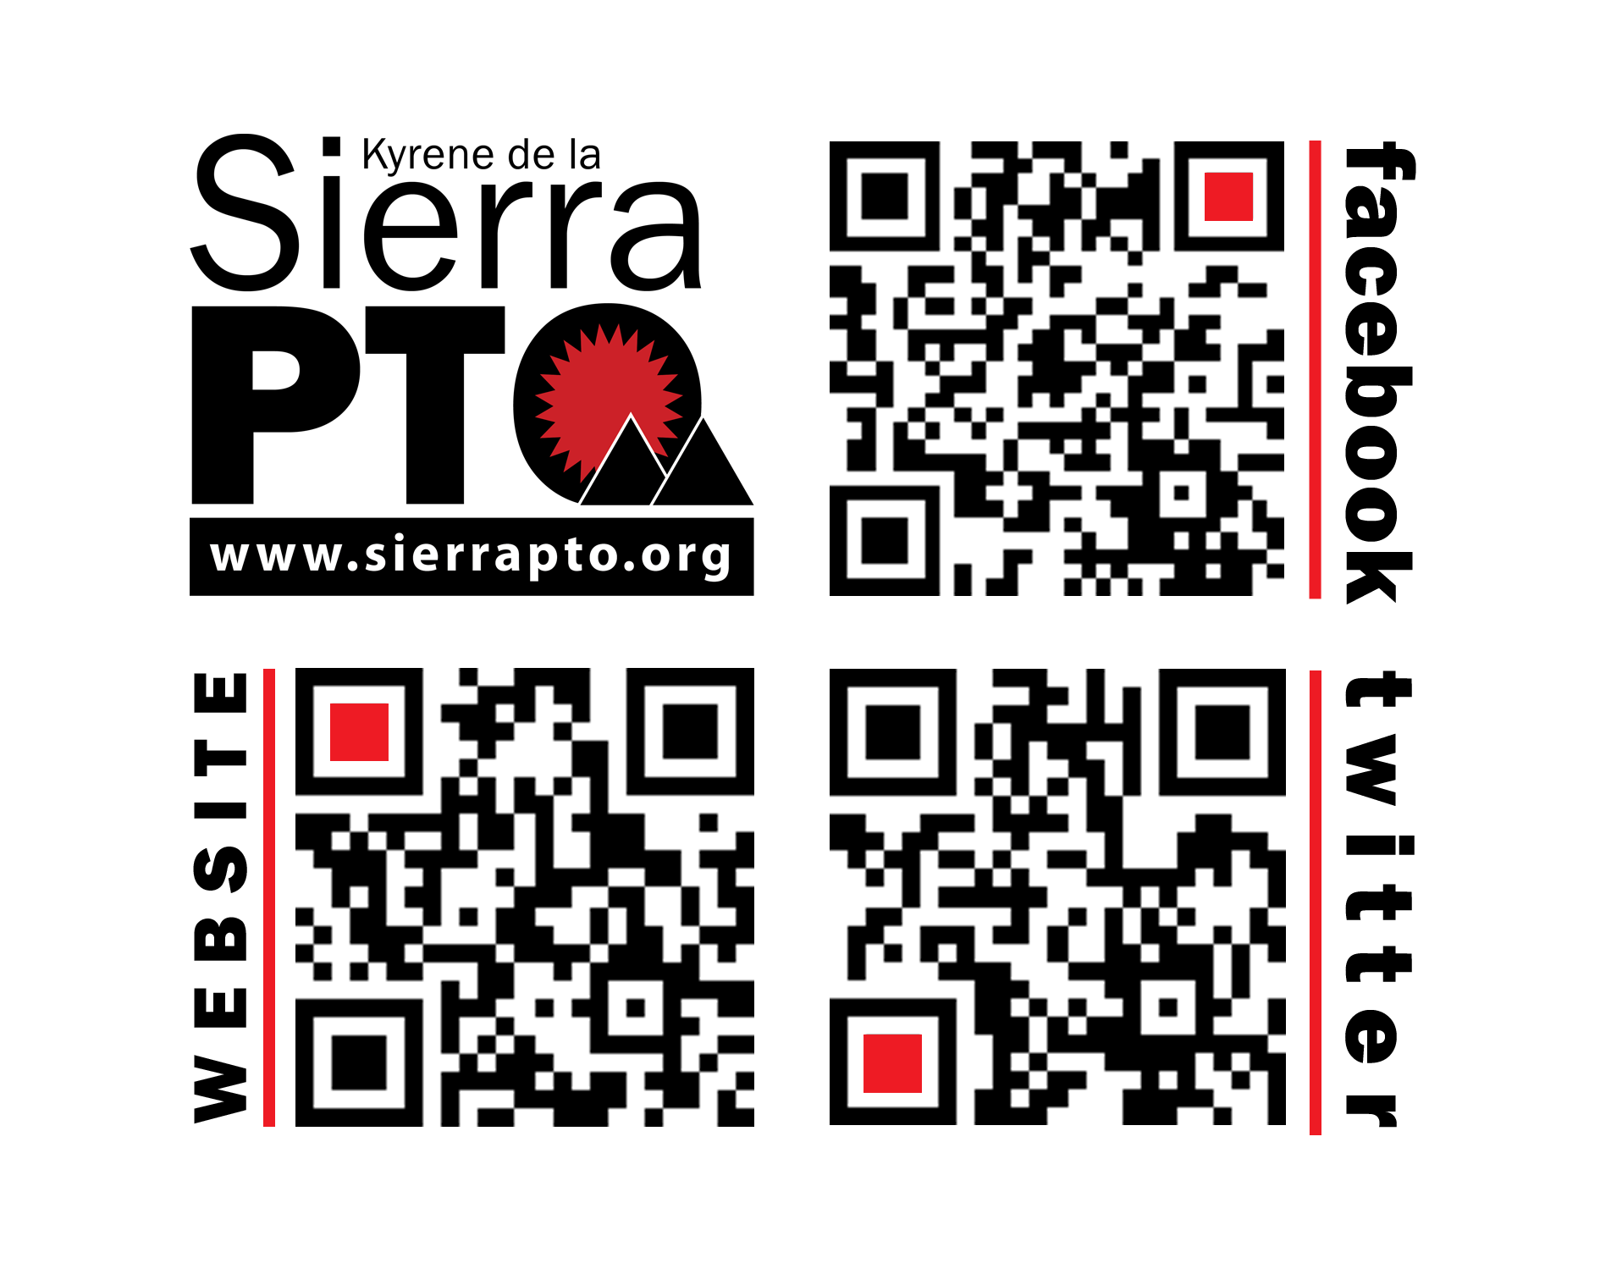**Liz Hill**Communications Coordinator  
[communications@sierrapto.org](mailto:communications@sierrapto.org)

Welcome to

Sierra PTO

Our PTO is a group of parents who are interested in supporting our school while fostering a fun community environment.

As a Sierra parent, you are already a member of our PTO. There are no membership dues or secret handshakes. We want everyone to feel welcome and encourage you to participate in any way you can.

As an all-volunteer organization, we need a lot of help from parents like you. **There** are no minimum requirements for volunteering! Whether you can spare one hour or a hundred hours, we welcome whatever contributions you can make. Even if you're unable to volunteer, you can still help by participating in our retail rebate programs. Read on and find out how!

## Three Things you can do right now to help

1. Fill our your **PTO Volunteer and Student Directory Form**. Access the form from your home computer at [www.sierrapto.org/documents](http://www.sierrapto.org/documents). This is our database of contact information that we use to communicate with parents and produce the annual student directory for Sierra families. Even if you are unable to volunteer, we still need your information so you don't miss out on school activities, contests, fundraisers, and prizes for your child.
2. Start saving **Boxtops, Campbells Labels, Tyson labels, and Coke Rewards**. Send them in to your child's teacher each week. These clippings earn our school hundreds of dollars each year, so every little bit counts!
3. **Register your Fry's and Safeway cards** so our school can earn a percentage of profits from your grocery purchases at **no cost to you**! For Fry's, please have the Fry's cashier scan the following barcode along with your Fry's card. For Safeway, sign up online at [www.escrip.com](http://www.escrip.com/).



## What Does the PTO do?

Our primary function is to support the Sierra staff and students by doing the following:

* Hold fundraisers for the school
* Purchase supplies and support continuing education for teachers
* Fund school improvements
* Provide volunteers to help with school activities
* Plan and execute fun events to bring the Sierra community together

## How Is OUR PTO Organized?

We are a 100% VOLUNTEER organized executive board and a number of committees, each of which is responsible for the various activities and fundraisers that take place throughout the school year. As you can imagine, it takes many people to make these events happen, and that's why we value your input and hope you will consider getting involved. Any amount of time is appreciated - big or small!

## List of PTO Committees

**5th Grade Committee** - Organize activities for the 5th grade promotion celebration.

**Book Fair** - Help with setup, cleanup, and working the fair..

**Fall Festival** - Help implement this favorite fall family celebration.

**Fall Fundraiser/BINGO Night** - Organize annual donation drive. Plan Family BINGO Night.

**Family Dance** - Help with organizing, setup and cleanup of this fun family event.

**History Wall** - Collect school memorabilia and organize annual display.

**Hospitality** - Plan and organize monthly menus for Sierra teachers and staff.

**Marquee** - Manage Sierra’s marquee by displaying events and school functions.

**Movie Night** - Plan movie night for Sierra families.

**Read-a-Thon** - Week-long reading celebration around Dr. Seuss’ Birthday.

**Restaurant Nights** - Implement fundraisers with local restaurants.

**Retail Rebate Programs** - Help collect and manage Box Tops, E-scrip, Coke Rewards and other retail rebate programs.

**Staff Appreciation Week** - Plan and implement staff appreciation activities.

**Student Directory** - Organize, print & distribute student directory.

**Spirit Wear** - Create logo gear for school store. Handle sales of school spirit items.

**Turkey Trot** - Outdoor fitness activity.

**Watch D.O.G.S.** – Volunteer program for dads and dad-like figures.

**Welcome Wagon** – Plans activities for families that are new to Sierra.

**Yearbook** - Take photos and design yearbook pages.